*• Rote memorization exercise with partner:* helping students to memorize complicated institutional setups

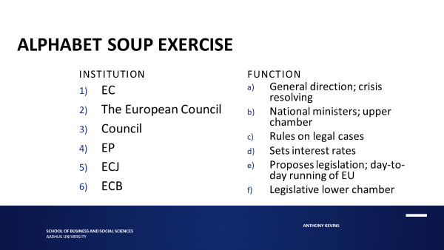

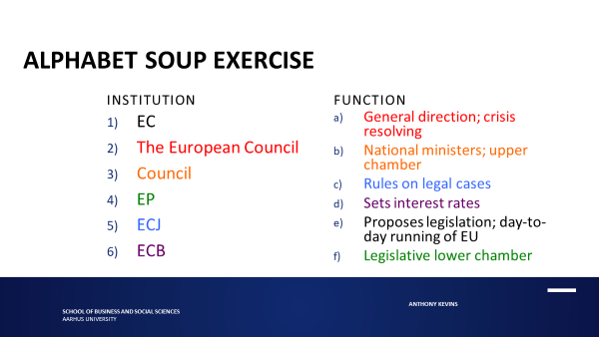

*• Recap exercise in small groups:* helping students to grasp unintuitive concepts

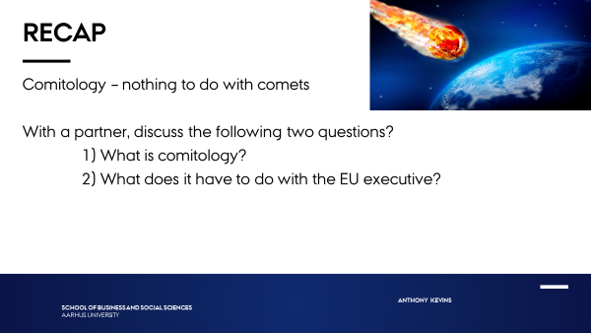

*• Two think-pair-share activities:* helping students to apply methodological concepts, with an eye to conducting (exercise on top slide) and analysing research (exercise on bottom slides)

*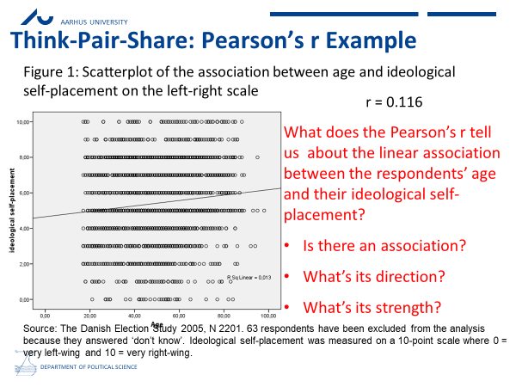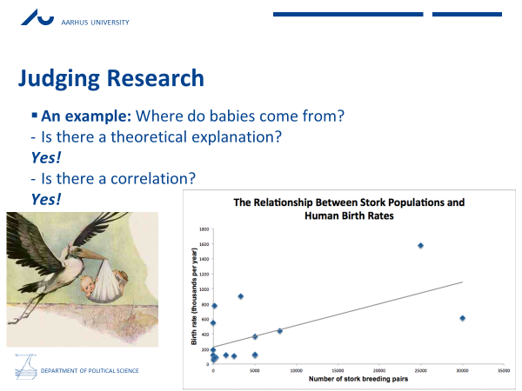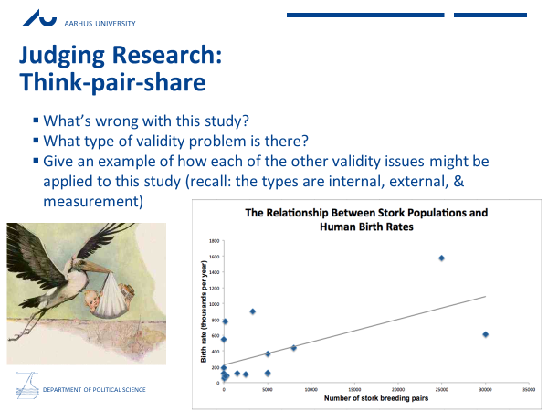*

*• Theory application group activity:* helping students to internalize a theory by applying it to the real-world (following brief introduction to the case)

